**BAB 2**

# DESKRIPSI PERANCANGAN PERANGKAT LUNAK

**Aplikasi Pemesanan Tiket Kereta Api**

## Dipersiapkan oleh:

Adiv Harjadinata(1301183484)

Dananjaya Cahyo Kusumo(1301180529)

Rifqi Zaidan Irsyad Yanis(1301180020)

Vharrel Devana Ismon(1301180033)

Program Studi Informatika Fakultas Informatika

Jl. Telekomunikasi 1, Dayeuhkolot Bandung

|  |  |  |  |  |
| --- | --- | --- | --- | --- |
|  | **Prodi S1- Informatika Universitas Telkom** | **Nomor Dokumen** | | **Halaman** |
| **DPPL BAB 2** | | 2 |
| **Revisi** | *-* |

1. **Deskripsi Perancangan Global**

### Deskripsi Arsitektural

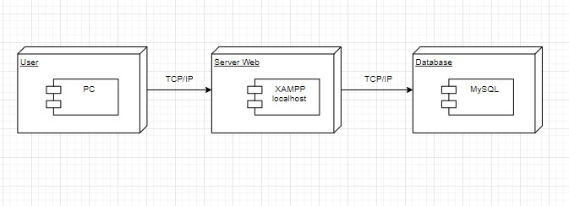

### Deskripsi Komponen

|  |  |  |
| --- | --- | --- |
| **No** | **Nama Komponen** | **Keterangan** |
| 1 | Pembeli | <<interface>> |
| 2 | Halaman awal | <<interface>> |
| 3 | Admin | <<component>> |
| 4 | Halaman Register | <<interface>> |
| 5 | Halaman Login | <<interface>> |
| 6 | Model Login | <<component>> |
| 7 | Pembayaran.php | <<interface>> |
| 8 | Keuangan | <<component>> |
| 9 | Pemesanan.php | <<interface>> |
| 10 | Pencetakan.php | <<interface>> |
| 11 | Halaman Status.php | <<interface>> |
| 12 | Status_pembayaran | <<interface>> |
| 13 | Booking | <<interface>> |

